What is Circuit Training?
Circuit training involves doing several exercises in a row, with short rest periods between each exercise. Once the circuit is completed, you then take another rest break and repeat the entire circuit again as many times as you want. Exercises for circuits tend to be quick and involve multiple joint movements. If you do not have access to equipment, you can do circuit training with just the weight of your body.
Circuit training typically involves a combination of eight to 10 high-intensity aerobic, anaerobic or resistance-training exercises that are designed to be easy to follow and enhance fat loss, muscle building and cardiovascular fitness. Each exercise is performed for a specified number of repetitions or for a designated length of time before moving on to the next exercise. A circuit is considered to be complete once all of the prescribed exercises in the program have been done. When one circuit ends, the exercises are then repeated for a second circuit.

Body Weight Circuit: (15-20 reps each)
- T-Push-ups
- Reverse Push-ups
- Bicycle Crunches
- Jack Knife Sit-ups
- Supermans
- Leaping Lunges
- Burpees

Upper Body Circuit
This circuit can either be performed for time or by completing a desired number of repetitions. To perform this circuit for time, complete 45 to 60 seconds, with no more than 30 seconds of rest in between each exercise. To perform this circuit using a set number of repetitions, complete 10 to 12 reps for each exercise, with 15 to 30 seconds of rest in between exercise. Perform three to four complete circuits before cooling down and stretching.
- Incline Bench Press
- Tricep Cable Pull-downs
- Pull-up/Chin-ups
- Cable Bicep Curls
- Lateral Raises

Lower Body Circuit

This circuit can either be performed for time or by using a desired number of repetitions. To perform this circuit for time, complete 45 to 60 seconds, with no more than 30 seconds of rest in between each exercise. To perform this circuit using a set number of repetitions, complete 10 to 12 reps for each exercise, with 15 to 30 seconds of rest in between exercise. Perform three to four complete circuits before cooling down and stretching.
- Hamstring Curls
- Squats
- Step Ups
- Calf Raises
- Glute Kickbacks
- Squat Jumps

Total Body Circuit
Each exercise in this total body circuit should be performed for 45 to 60 seconds, with no more than 30 seconds of rest in between each exercise. Perform two to three complete circuits before cooling down and stretching.
--Bench Press
--Squats
--Jumping Jacks
--Military Press
--Walking Lunges
--Bicep Curls
--Jumping Jacks
--Tricep Extensions
--Sit-ups
--Plank

Circuit Training Guidelines
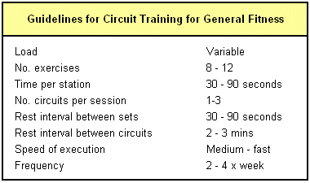
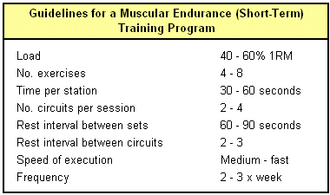

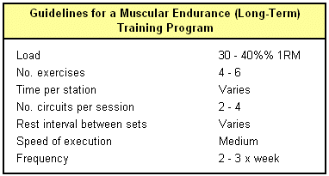
Sample 20 Minutes Circuit Workout
This workout is 20-minutes. The object of this workout is not to rest in between exercises. You will see that one minute of a particular exercise will burn out the targeted muscle group as well as increase your heart rate to a fat and sugar burning zone. Try the workout below - if it is not challenging enough for you try it again, totaling only 40 minutes of your time.
1) Jumping Jacks- max in 1:00
2) Squats - max in 1:00
3)Bench press* or pushups - max in 1:00
4) Leg curls - 1:00 (requires leg machines - or repeat lunges with weights)
5) Pullups or pulldowns - 1:00
6) Bike or jog - 3:00
7) Lunges - 1:00 each leg
8) Shoulder press* - 1:00
9) Bicep curls - 1:00
10) Bike or jog - 3:00
11) Squats with weights - 1:00
12) Tricep extensions - 1:00
13) Face Down Plank - 2:00
13) Crunches - 2:00

