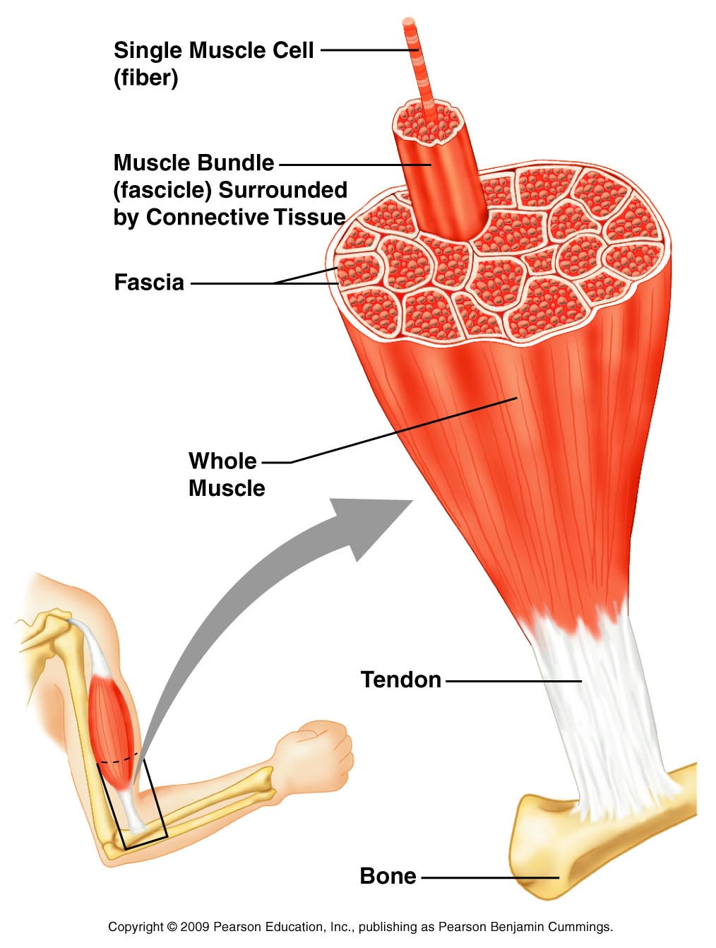
KIN 119: Muscles
Structure of Skeletal Muscle:

- Single muscle cell (fiber)
- Muscle bundle (fascicle) surrounded by connective tissue
- Fascia
- Whole muscle
- Tendon (connects muscle to bone)

Motor Unit:
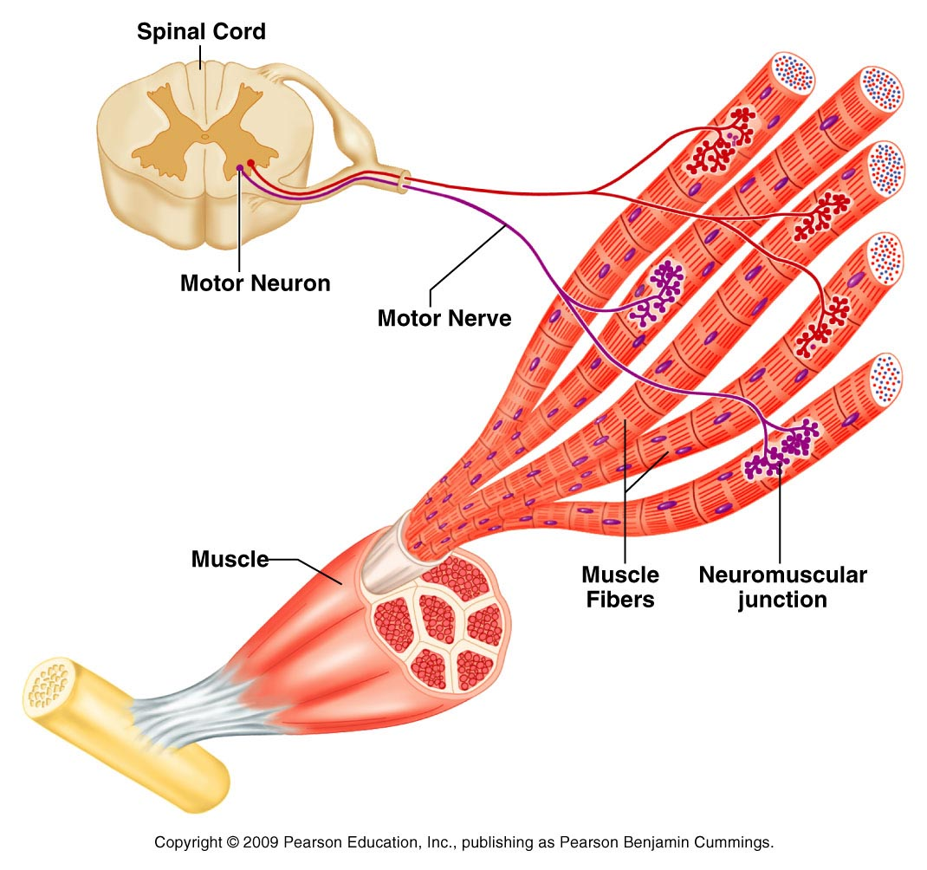
- Motor neuron
- Motor nerve
- Muscle fibers it innervates (neuromuscular junction)

Categories of Muscle Contractions

- Isometric: Actions are static and involve no movement. Tension builds.
- Isotonic: Dynamic movement of a body part at a joint
  - Concentric (positive work)
    - Causes movement of a body part against resistance or gravity; Occurs when muscles shorten
    - Example: upward arm movement during a bicep curl
  - Eccentric (negative work)
    - Controls movement of a body part with resistance or gravity; Occurs when muscles lengthen
    - Example: downward arm movement during a bicep curl
Muscle Fibers Types & Sports:

- Slow-twitch fibers:
  - Contract slowly; Generate little force but are resistant to fatigue
  - Examples: Marathon, Distance Running, Distance Swimming, Rowing
- Fast-twitch fibers:
  - Contract quickly; Generate lots of force, but fatigue quickly
  - Examples: Fencing, Field Events, Sprints, Olympic Lifts, Baseball, Softball, Tennis, Volleyball
- Intermediate fibers:
  - Combination of other two types: contract rapidly, produce great force and resist fatigue
  - Examples: Basketball, Football, Ice Hockey, Lacrosse, Soccer

Some Muscles in the body
