pH Food Chart
Try to eat mostly foods from the Alkaline section (pH 8-10) and limit or avoid the Acidic section (1-6)
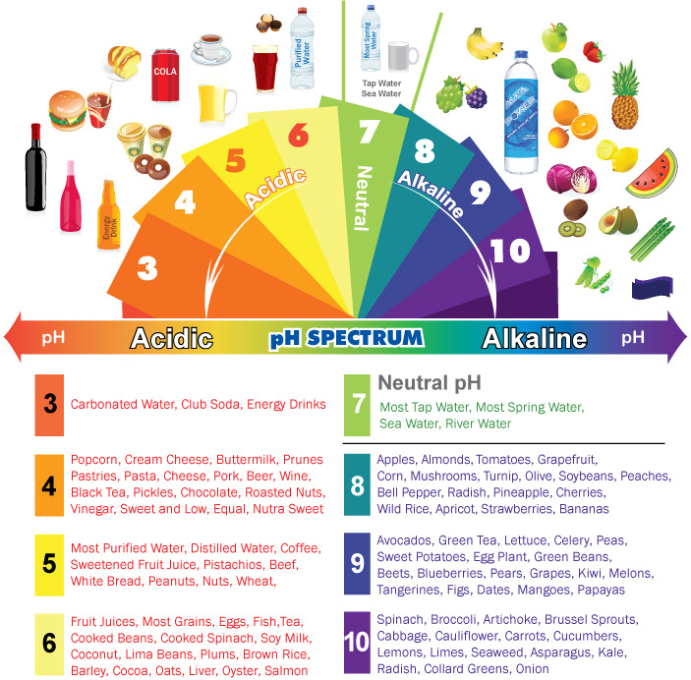
Food Combinations and Choices
Try to eat mostly food combos in the Excellent or Good connection:
