Plank exercises:
Maintain an isometric position while contracting certain muscles or muscle groups for a certain length of time. It is very effective in exercising and strengthening your core muscles:
- The Transverse Abdominis, the muscles the lie deep beneath the obliques that wrap around your spine to protect it and give you stability;
- The Rectus Abdominis – extending along the front of your abdomen and is more commonly known as the “six-pack” muscles
- The Erector Spinae - the muscles that run along your lower back up to your neck
- The External Obliques or the “love handle” muscles around your waist
- The Internal Obliques which is located under the external obliques.
As well as other muscles:
- Upper-body muscles - including the pectoral and serratus muscles
- Lower-body muscles - the quadriceps, tensor fasciae latae & sartorius
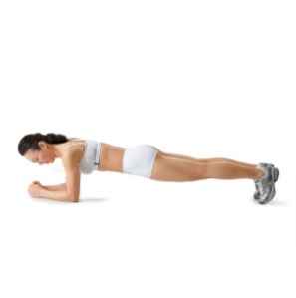
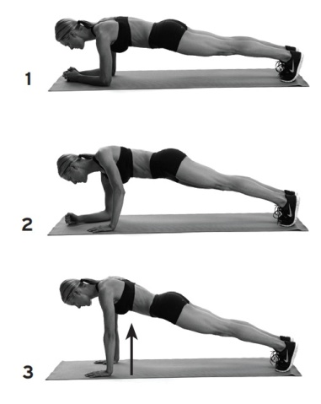
Variations of Planks:
- Face Down Plank Face Down Plank to Pushup

- Side Plank
- Glute Bridge
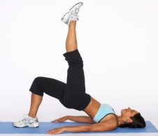

- Glute Bridge with leg extended

- Face Down Plank with extended arm

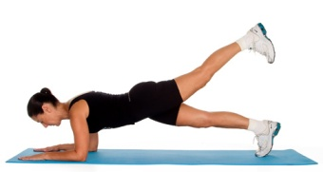
- Face Down Plank with extended leg

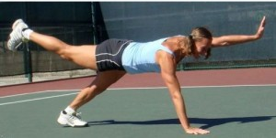
- Extended arm and leg Plank

