Speed & Agility Drills

General Guidelines for Speed and Agility Drills
Quality is the key for successful performance of these speed and agility drills. Keep the individual sprints short and rest completely between sets. Use these 6 pointers to optimize the training response:
1. Warm up thoroughly. Speed and agility drills may not leave you out of breath but they do put considerable strain on your musculature.
2. Speed and agility drills should be performed either on a separate day to other training or at the start of a training session after the warm up.
3. You will gain most benefit from the speed and agility drills if you have previously developed a solid strength and power base.
4. A typical session may consist of approximately 5 sets of 10 repetitions (each sprint being 1 repetition). Work to rest ratio should be 1:5 i.e. a 5 second sprint should be followed by a 25 second recovery period.
5. The number of sessions per week varies greatly. For most team sports speed and agility drills should be introduced late on in the pre-season phase. Two sessions a week is usually adequate. During the competitive season, one session per week may be enough. Sprint athletes may need as many as 3-5 sessions per week.
6. The speed and agility drills below are suitable for many sports. To make them more specific adapt them slightly to mirror the movement patterns in your game. You'll find some examples below.
Choose 2 or 3 of the speed and agility drills below to make up the session, keeping to the recommended number of sets and repetitions.

Speed Drills
1. Basic Sprints
Set 2 cones out 10-20 meters apart. Sprint from one cone to the next and slowly jog back to the start. Vary the start of the sprint to make the drill more sport specific. For example...
Face backwards, lie down, jump up, pretend to receive a pass, jump to head a ball etc.
2. Rolling Start
Exactly the same as above except you jog for 10 meters before sprinting. This drill is specifically designed to enhance acceleration rather than speed off the mark. Try running backwards or side stepping as well.
3. 40 Yard Sprint
Exactly the same as above except you sprint for 40 yards.
4. Up Hill Sprints
In competition the first few strides are crucial. Running up a slight hill (about 30 degrees) helps to develop power and acceleration. Keep the distances short (10-15 meters) and allow extra rest between sets and reps.
5. Down Hill Sprints (Over speed training)
Down hill speed and agility drills help to develop leg speed and co-ordination. This is sometimes referred to as over-speed training. Keep the distance short (10-15 meters) and make sure the hill is only slight.
6. Hollow Sprints
Set 5 cones out in 30 meters intervals. Sprint 30 meters, jog 30 meters, sprint 30 meters and jog 30 meters to the final cone. Walk back to the start and repeat.
7. Cruise and Sprint
Mark out a distance of 100 meters. From the start gradually accelerate to reach full speed at about 60 meters. Sprint all out for the final 40 meters.
Reduce the number of repetitions for this exercise as it takes longer to complete.
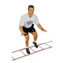
Agility Drills
- A ladder is a simple training device that helps to improve co-ordination and leg speed. It can be used for a number of speed and agility drills and is particularly useful for sports such as tennis and basketball that requires fast and co-ordinated footwork.
2. The Snake
Set up a series of 6-8 cones in a straight line about 1 meter apart. Weave through the cones, turn and weave through back to the start.
3. Follow The Leader
A training partner and large area is required for this drill. Have your training partner jog, run and sprint randomly over a large area. You must try to shadow her as closely as possible. This is an excellent drill that helps to develop reaction time, acceleration and speed endurance.
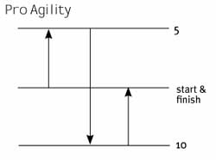
4. Pro-Agility (5-10-5)
- Start in a 2-point stance straddling the starting line.
- Open to your right or left; sprint 5 yards; touch the line with your hand.
- Turn and sprint 10 yards and touch the line with your hand.
- Turn and sprint 5 yards through the finish line.

5. L- Drill (3 Cone Drill)
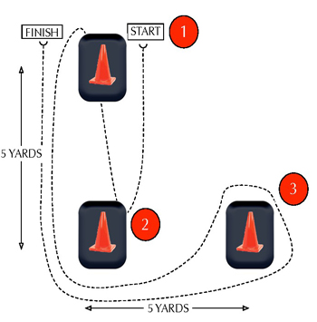
- You need 3 cones set up 5 yards apart from each other in the shape of an L.
- This will end up looking like you are one cone short of a complete square.
- Start in a three point stance (like you would in a 40yd dash).
- Touch the line at the first cone with your hand.
- Return to the starting cone and touch the line with the same hand.
- Note: whichever hand you choose to touch the line with has to be used both times.
- Sprint around the middle cone and figure 8 around the far cone.
- Make a turn at the middle cone and finish through the line. Use your speed to accelerate as fast as you can around that cone.
- The clock starts at first movement and stops when you have crossed the finish line after the full 30 yards.

Reference: http://www.sport-fitness-advisor.com/agilitydrills.html

